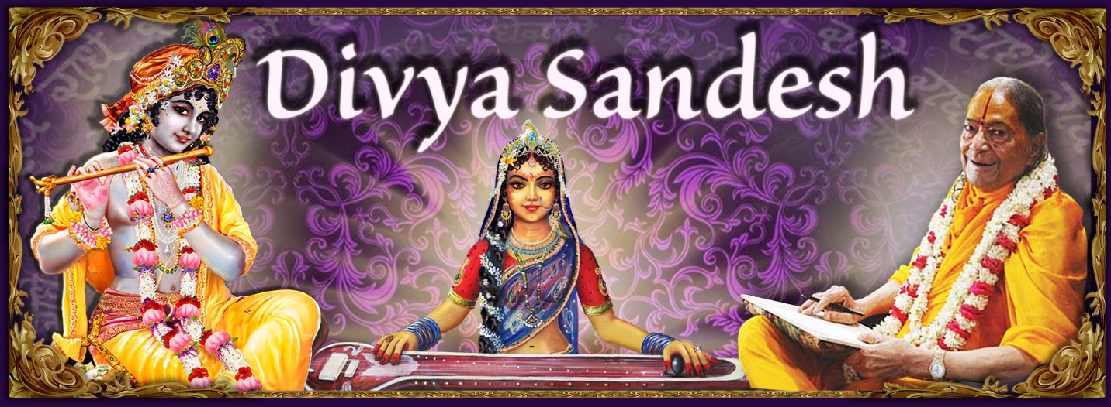

2019 Guru Poornima

Is there happiness in the world?

Question:
The Vedas say that there is no happiness in this world. However, our experience states otherwise. We do find happiness in material matters. Moreover, since this life is temporary and will be lost one day, why not enjoy material matters while we live?

Answer:
The words of the Vedas are eternal and irrefutable. Yet, to some extent it is also true that material beings experience happiness in worldly accomplishments such as acquiring wealth, getting married, having children, attaining fame etc. So, let us try to understand, how both the above statements are correct.

It is a universal truth that without receiving any formal training to desire and look for happiness, every living being from an insignificant ant to the creator Brahma, is searching for happiness. To convince yourself that this statement is indeed true, try asking a small child, “Honey! Why do you go to school when you get so much homework? This is your age to play and have fun.”

The child would reply, saying, “I go to school, so I can study, get good grades and move on to higher grades.”

You further ask, “Why do you want to go to higher grades?”

Index

Is there happiness in the world? | Page 1
Kripalu Leelamritam – Our Guru Knows | Page 6 | Bhakti gives rise to divine virtues | Page 7

He would answer, “So I graduate from the school with good marks and get an admission into a reputable university.”

Ask again, “Why do want to get an admission into a reputable university?”

The child might say, “To land with a high paying job.”

And you’d ask, “Why do you want to get a high paying job?”

The answer will be, “So I can buy everything I need for leading a comfortable and happy life.”

If you were to ask the last question at this time, “Why do you want to lead a happy life?”, there would be no answer to this question. In fact, the child may even pose a question back to you, saying, “Everyone wants to be happy, don’t you?”

You might want to ask the same set of questions to a businessman, lawyer, office worker, player, musician or a saint. Regardless of who you ask, everyone will end up with the same answer, that all their actions are towards a singular purpose of attaining happiness. This proves beyond a doubt, that no-one can perform any action to achieve anything other than happiness.

The reason of this universal desire is stated in the Vedas. The Vedas say:


"Jeev is an infinitesimally small fraction of God”.

The Gita says more explicitly:
 
“All living beings are My eternal and inseparable parts”. The Ramcharit Manas says the same:

"Jeev are eternal and infinitesimally small fraction of that God, who is sentient, divine and an ocean of bliss”.
So, we are a part of God. But who is God? The Vedas say again:
□ 
“God is bliss.”
We tend to say in ordinary terms, “there is bliss in God”. This statement is incorrect, for if there was bliss in God, God and bliss would be two separate entities. God is bliss personified. God’s body is not made of bones and flesh. It is made of bliss, exactly like the sugar figurines is made purely from sugar and nothing else.
All living beings are a combination of two components the body and the soul. The soul is eternal and divine and it dwells inside the body. The body is temporary and made up of material matters (panch mahabhoot).
We are the soul and this body is given to us, with the sole objective of realizing the ultimate goal of life i.e. attaining permanent, ever-lasting, ever-increasing happiness.
Figure 1:sugar figurine is made purely from sugar and nothing else
The body is equipped with 10 sensory organs, a mind and an intellect. This human body can be compared to a horse drawn carriage or a chariot and the soul to a passenger. The Vedas say:
     

“The soul is the master and sits like a passenger in the chariot called body. The intellect is the charioteer, the mind are the reins, the senses are the horses and the matters of the world are the visible range.”

The passenger orders the charioteer to drive him to Anand Nagar - the abode of happiness. The charioteer has no idea of this place and asks his master for the whereabouts of Anand Nagar. The passenger - soul is a non-doer. It does not provide any direction but instructs the charioteer to take him to the abode of happiness. The intellect orders the mind; the mind in turn orders the senses to get the various matters of the world, hoping one of them would be the source of happiness for the master. The soul has rejected all the material happiness offered to it, since eternity.
There however is one technical problem:

“The reach of these servants (senses, mind and intellect) is confined to the area of Maya”.

The soul is divine and desires only for divine happiness, while the servants at its disposal are all material, hence only perceive and offer material objects to the master. This is the reason why the senses, the mind and the intellect are ceaselessly engaged in searching happiness since eternity yet have failed to please their master.
For instance, the eyes find beautiful things to see and pass them on to the mind. The mind forwards it to the intellect and the intellect to the soul. The soul says, “this is not my subject. I am divine. Bring me something with divine beauty.”
Likewise, the ears bring pleasant words, sounds and music. The nostrils bring lovely fragrances. The tongue brings delicious tastes and the skin the soothing touch of innumerable things. Yet none of them could satisfy the one and only desire of their master.
The definition of happiness is:

“That which is infinite and lasts forever is happiness.”
The community of charioteers (the intellects of various individual beings) get together and discuss how best to please their masters. As per their limited depth of understanding of the concept of happiness, they suggest different means like wealth, health, fame, family, position etc. to please the master.
Consequently,

“when a blind leads a blind, both fall in a pit”. Since eternity we have been following the advice of ignorant beings. Hence despite all the hard work, we are still devoid of true happiness; not only that we are getting unhappier.
Now, let us reflect on this point - why do we continue to strive for worldly happiness despite the awareness that God is the only source of happiness?
There are two concepts of happiness. One is called shreya () and other is called (). Shreya means adorable and preya means enjoyable. Then the Vedas say:


“Those who choose shreya follow the path of God realization. They are released from the clutches of Maya and attain true bliss, which is divine and unlimited. Those who choose the path of preya, are engaged in momentary sense gratification and eventually pay for their negligence, by wandering in 8.4 million species of life.”
Preya means pleasing to the senses. Senses are material. Hence material matters please the senses. Maya creates inert objects that are perishable in nature. Even while the objects last, they can be relished only for a short period after which the same matters become a source of grief. Say for example, you are very thirsty and are offered a glass of water. As you keep drinking 1, 2, 3 glasses of water, your thirst gets quenched. Now if you are forced to continue drinking water, you will eventually throw up. Such is the nature of material happiness. The same thing that gives you happiness one day, becomes a source of sorrow at a later time.

Most of us think wealth is the best resource of happiness. But, look at the most opulent people in the world. Are they satisfied with whatever they have? If yes, then why do they continue to work so diligently and exercise fair and unfair means to earn more wealth?

When Baman Bhagwan went to King Bali and asked for 3 steps of land, Bali laughed on his innocent desire and offered villages, gems, elephants and horses. Bhagwan smiled and said, “O king! No amount of wealth can satisfy a human being. You have so much wealth that you can donate any amount of it to a mendicant, yet it won’t make any significant dent in your wealth. But are you satisfied? If yes, why then are you performing this yagya?”

Ved Vyas Ji says in the Bhagwat:


“If the wealth of this entire earth is bestowed upon one person, he will still desire for more”.

So, those who are ignorant, concede to preya. In their innocence, they try to extract butter by churning lime water, thinking it to be milk. In accordance with their expectations, they derive some joy upon obtaining that object but that joy lasts only for a little while, eventually disappears and ultimately gives rise to sorrow and misery.
Our eternal scriptures suggest, instead of accepting the myth of happiness, a wise person must ponder on what is real happiness, where and how should he find it? Real happiness is:
- unlimited,
- for an unlimited time,
- is ever new and ever increasing.
The joy of delicious food, children, beauty and position etc. is limited and transitionary and eventually loses its charm.
If expending the same amount of effort in 2 different areas were to yield two very different results i.e. momentary sensual gratification and the pain of roaming in 8.4 million life forms OR ever-lasting, ever-increasing happiness and freedom from all miseries forever, what would you choose?
In the first scenario, there is pain along the way while earning material happiness. Then there are problems in securing it. And in the end (because everything is temporary) there is pain in losing it.

It is also imprudent to think that death relieves us of all the problems. The sufferings we experience today continue until eternity or until we attain the goal of life i.e. divine happiness.
But, on the path of shreya, there is no loss of any kind. Just by remembering God with an unwavering faith, at all times in all places, would keep you forever contented and happy. To acquire knowledge about this path one has to take shelter at the lotus feet of a true saint, who is both well versed in the scriptures (□) and is also God-realized ().
 □   □  
Our scriptures instruct us to not waste any time and start following the path of God-realization () as soon as possible, since doing so is possible only in the human form. But the human form is temporary and no-one knows when the moment of death will come. If we waste this human form, we will be forced to roam in the 8.4 million species of life forms for millions of years, before we get a human birth.

This world is not a dull, boring place. The all-blissful God permeates each and every particle of this universe. The saints are ever-blissful living in the same world, experiencing God everywhere.

However, the matters of the world are dull and lifeless. Do not overuse and relish them. While living in this world, be always delighted feeling the presence of God with you.

Kripalu Leelamritam – Our Guru knows

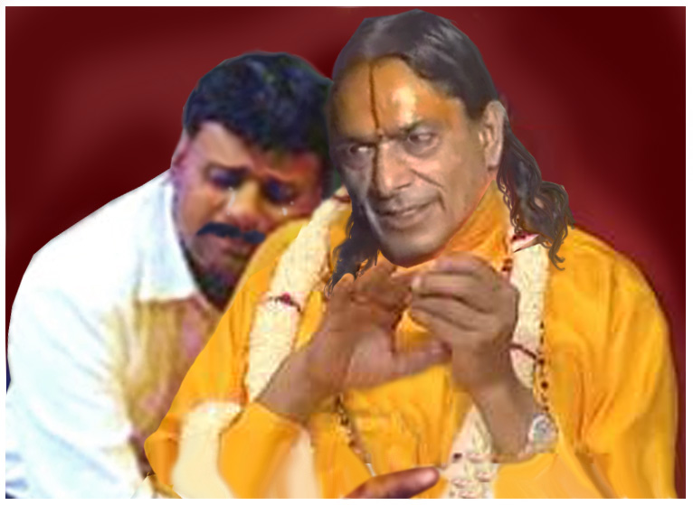
This is a true incident that happened over forty years ago. There was a devout couple who had a small temple in their house where they had established a metallic idol of Shri Radha Krishna. As per her daily routine, the lady of the house used to scrub the idol with wooden ash before washing it off to keep it bright and shiny. When this couple met Shri Maharaj Ji for the first time, Shri Maharaj Ji pointed out to his rough skin and said, “See your wife scrubs me so hard with wood-ash that my skin is peeling. This daily scrubbing causes me pain.”
Figure 2: Maharaj Ji said,"Your wife scrubs me with wood-ash. See how my skin is peeling off".
The husband understood what Shri Maharaj Ji was saying and tears of repentance started rolling down his eyes. From that time on, his entire family took shelter under the lotus feet of Shri Maharaj Ji.
One day, their 5 year old son disappeared from their home. Everyone started looking all over but could not locate the child. At 5am the next morning, there was a knock on the door and the little boy was standing at the door unscathed. Everyone was anxious to know where had the child been. He told them how he had been kidnapped by 4 people. He further said, “That man, whose picture we have on the wall in our house, came from somewhere and fought with all those people to save me. Then he brought me here, knocked on the door and when you opened the door, he left.”
Everyone knew at that moment that it was Shri Maharaj Ji who had come to save the little boy. Shri Maharaj Ji, not only takes care of the spiritual needs of the surrendered devotees but also looks after their material well-being.
After these incidents, the family’s faith in Shri Maharaj Ji increased even further. The husband, an ardent devotee of Shri Maharaj Ji remained engaged in performing mental sewa, such as pressing Shri Maharaj Ji’s lotus feet after he was asleep or fanning Him during the summer months.
A good devotee does not ever talk about their feelings or devotion, but sometimes to help someone, they may say things that illustrate the state of their devotion and selfless love. One day, while chiding another devotee for crying out to Maharaj Ji for help, the husband said, “if you cry out to Shri Maharaj Ji for help after he retires in the night for sleep, how will he ever fall asleep listening to your cries”.
Such beautiful sentiments of love for Shri Maharaj Ji, are a great source of inspiration for all aspiring devotees.
Moral: In Gita, Shri Krishna says:
ये यथा मां प्रपद्यन्ते तांस्तथैव भजाम्यहम् |
“I reciprocate the feelings of my devotees with the same sentiment and with the same intensity as that of the devotee’s feelings towards Me”.
When the feelings of the devotee are so pure and soft, God reciprocates the same feelings, thereby providing the devotee with indescribable bliss.

Kid’s Story – Bhakti gives rise to divine virtues
Figure 3: Mother Teresa was humble and kind
This is a true incident from the life of Mother Teresa.
Mother Teresa used to identify financially well-to-do individuals and asked them for donations to help those in need. One day she knocked on the door of a rich businessman, who was not a believer in sharing his wealth with others. He was an egoistic man, full of pride. Upon hearing the knock, he answered the door, only to slam it on Mother Teresa’s face. Unaffected by the insult and driven by her desire to help the poor and underprivileged, Mother Teresa knocked the door again. This time he opened the door and spat on her face. Mother Teresa wiped off the spit from her face and knocked yet again. When he answered the door the third time, she said to him in a very calm voice, “You gave me what I deserved, now what will you do for the kids?”.
The rich man was stunned by her response. He could not believe that someone could be so kind and humble as Mother Teresa was. He was immediately consumed by a strong sense of shame and remorse and was a changed man from that point on. He decided to donate all his wealth for the care and well-being of the poor, destitute and needy children.

Moral: Humility, serving others, selflessness, patience etc. are divine qualities. Material beings can practice to imbibe these qualities and can even be partially successful. However, it is only after God-realization that all these qualities come naturally and are here to stay. So, we must first work towards attaining God-realization and then all these virtues will follow naturally.

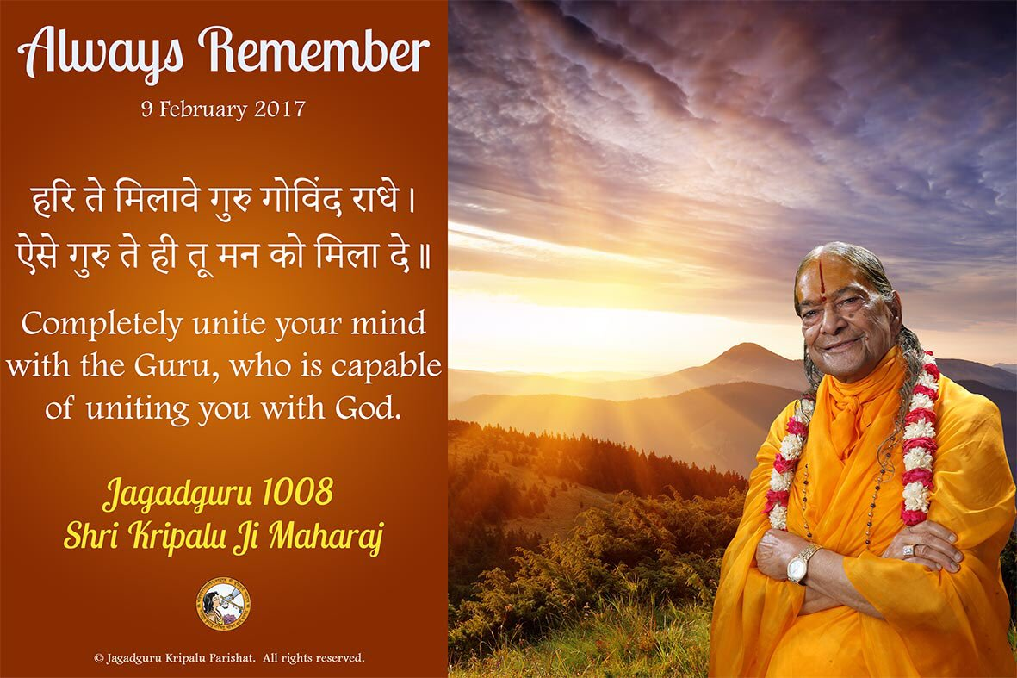

On Guru Poornima countless obeisance

to our Beloved Gurudev

Jagadguruttam Shri Kripalu Ji Maharaj

